April 8, 2024
Village of Skaneateles 26 Fennell Street Skaneateles, NY 13152
Dear Village Board,
It’s been a privilege for Grace Chapel to be a part of the Skaneateles community and to have enjoyed a positive relationship since our beginning 42 years ago. We believe God has placed us within this community to add value and strength to the individuals and families that reside here.
I am writing to request permission to use Cilft Park again this year for a baptism service in the Lake on Sunday, August 4th. Many of our members and attenders have grown up in this community where the village and lake are very meaningful to them. To have a baptism service in the lake would be a special way to tie a significant spiritual practice with the local community in which they worship.
We would provide all needed support such as a lifeguard, and any other important support needs that you determine necessary. Our plan is to accomplish this between 10:00am and 11:00 am when there is no conflict with parking, events or regular business hours for the village stores. We would also encourage our congregation to take the opportunity after the service to patronize the local businesses.
I know last year there were some concerns expressed that I would like to speak to. The first was in regard to the 2 ez-up tents and tables we set up. We will eliminate any tents and tables. We used them this last year to protect our written material and sound equipment from getting wet in case of rain but we will find other ways to accomplish those needs. Another concern which was mentioned was getting there to early and yes we had some of our people out of excitement get there early to set up which we will change. We typically need about an hour prior just to walk through things and set things up. There was also something said about the sound and I can assure you that nothing has changed with the sound over the past 10 years. We are very respectful in regard to it.
Thank you for taking this into consideration and feel free to contact me with any further questions or concerns. You can contact me at barry@gconline.org or 315-685-3071.
Sincerely,
Barry Sisson Senior Pastor
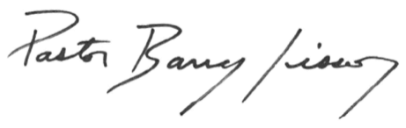
1674 U.S. Route 20, Skaneateles, NY 13152 Office: 315.685.3071 www.gconline.org

