**From:** Ilana Cantrell <[IlanaCantrell@ongov.net](mailto:IlanaCantrell@ongov.net)>   
**Sent:** Tuesday, January 23, 2024 8:35 AM  
**To:** Ilana Cantrell <[IlanaCantrell@ongov.net](mailto:IlanaCantrell@ongov.net)>  
**Subject:** Onondaga County Planning Federation 35th Annual Planning Symposium

The Onondaga County Planning Federation's 35th Annual Planning Symposium will be held on March 13, 2024 at the Marriott Syracuse Downtown. Please click on the link below to view the program and registration materials:

<http://ongov.net/planning/ocpf.html>

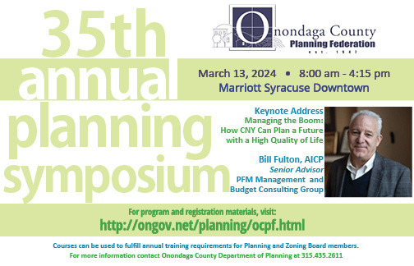

Ilana Cantrell  |  Planner

Email: [ilanacantrell@ongov.net](mailto:ilanacantrell@ongov.net)

Main: (315) 435-2611  |  Direct: (315) 435-8573

Website: [www.ongov.net/planning](http://www.ongov.net/planning)

Carnegie Building, 1st Floor

335 Montgomery St, Syracuse, NY 13202

